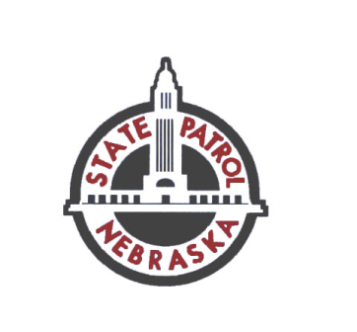**Nebraska State Patrol**

Crime Laboratory Division

Due to expansion construction at the NSP Crime Laboratory,

Case Management staff will

**NOT BE ACCEPTING EVIDENCE SUBMISSIONS NOR RETURNING ANY EVIDENCE JULY 2 – 3, 2025.**

Evidence transactions **through appointment only**

will resume July 7, 2025.

Contact the Lab at 402-471-8950 for Urgent Evidence Questions